|  |  |
| --- | --- |
| cetlogo ***CHEMICAL ENGINEERING TRANSACTIONS***  ***VOL. , 2023*** | A publication of  aidiclogo_grande |
| The Italian Association  of Chemical Engineering  Online at www.cetjournal.it |
| Guest Editor: Sauro Pierucci  Copyright © 2023, AIDIC Servizi S.r.l. **ISBN** 978-88-95608-98-3; **ISSN** 2283-9216 | |

Parametric optimization of re-refining of waste lubricating oil using bio-flocculant via Taguchi approach

Sayantan Sarkara, Deepshikha Dattab, K S Deepakc, Bimal Das\*a

aDepartment of Chemical Engineering, National Institute of Technology Durgapur-713209

bDepartment of Chemistry, Brainware University, Barasat, Kolkata, India-700125

cDepartment of Mechanical Engineering, Birla Institute of Technology & Science Pilani, Hyderabad, India- 500078

bimal.das@che.nitdgp.ac.in

Over the past few decades, recycling used lubricants have drawn much attention as a cleaner technique. The current study focuses on the fabrication and application of bio flocculant (sodium alginate) from brown algae (*Sargassum Muticum*) for the refining of waste lubricating oil. Further the work illustrates on the optimization of the four process parameters like refining time, refining temperature, solvent-to-waste oil ratio, and flocculant dosage at three different levels (low, intermediate and high) using Taguchi approach during the process of refining of waste lubricating oil by clean and environmental friendly extraction flocculation method. The optimized parameters for maximization of the yield (91.31 %) were observed at refining time of 60 minutes, refining temperature of 80 ℃, a solvent-to-waste oil ratio of 3:1, and a flocculant dosage of 1 g/kg of solvent. A good fit of the model could be achieved with a R2 of 0.9938 and p value of 0.018. The re-refined lubricating oil had a flash point, pour point, kinematic viscosity@40 ℃ and 100 ℃ of 234 ℃, -33 ℃,155.21 cSt and 17.11 cSt which are comparable to the virgin lubricating oil and hence refined oil can remarkably be used for specific purpose in automotive engine after addition of requisite amount of additives.

* 1. Introduction

Lubricating oil, during its prolonged uses diminishes its quality with time due to formation of oxidative products, degradation of additives, contamination with water, gasoline or metals from metallic surfaces, and carbon particles (Mensah-Brown, 2015). The indiscriminate disposal of waste lubricating oil into the environment may pose a major threat to the ecology (Sarkar et al., 2022) offering a high risk of damaging the soils, water and air. The negative impacts of inappropriately used oil management on the environment and human health (Botas et al., 2017) necessitate investigations for regeneration of waste lubricating oil to produce new lubricants, promoting a 90% decrease in the environmental problems that can shoot up from the manufacturing of petroleum-derived products (Botas et al., 2017). Various scientific investigations across the globe have been carried out over the decades for waste oil recycling as a mitigative measures of waste management. Extraction flocculation technology, is one of the most suitable green technology for re-refining of waste lubricating oil considering today's environmental feasibility aspects, as it is independent of feedstock nature and produces less harmful and reusable by-products (Osman, Attia and Taman, 2018). Synthetic or organic flocculants can attain good efficiency, but it would have a high risk of difficult bio-degradability (Chen, Si and Fatehi, 2018). Biopolymer-based flocculants are referred to the long chain molecules produced by the plant or living organism, and it has many properties such as, wide source, easy modification, environmental friendliness, low dosage required for good flocculation efficiency (Renault et al., 2009). The development of the seaweed-based bio flocculant is environmentally benign, biodegradable, and biocompatible (Mahmoud and Mohamed, 2017). The most adaptable polysaccharide found in nature is sodium alginate, a biodegradable, non-toxic polymer that is isolated from brown seaweed (Jayasinghe, Jinadasa and Sadaruwan, 2022). Present investigation focused on synthesis and application of novel biopolymer flocculant (Sodium Alginate) in re-refining of waste lubricating oil. In addition, application of the Taguchi approach of factorial optimization of operational parameters for maximization of yield of re-refined base oil has also been investigated which is not yet reported in any literature.

* 1. Materials and Method
     1. Materials

Brown algae (*Sargassum Muticum*) were collected from nearby pond of NIT Durgapur. Various chemicals such as sodium carbonate, methanol and hydrochloric acid were procured from Merck, India. Re-refining of waste lubricating oil was carried out utilizing 1-butanol as solvent (99 % purity), and fuller’s earth as adsorbent. All these chemicals are provided by EMPARTA, Mumbai.

* + 1. Methods

Development of biopolymer flocculant

The dried Brown algae (*Sargassum Muticum*) sample was weighed (60 g) and soaked in 80 ml of 2% (v/v) methanal solution for 24 h at room temperature to eliminate phenolic compounds and pigments. After three washes with deionised water, 80 ml mineral acid (HCl) (0.2 M) was added to the solution and left for 24 hours to remove polyphenols and fucoidans (Bertagnolli et al., 2014). The seaweed biomass is washed with deionised water before extraction with 2% sodium carbonate for 3 h at 80 ℃. The sodium alginate is then liberated from the seaweed biomass matrix and transported into the liquid phase (Saji et al., 2022). Centrifugation (12,000 rpm for 30 minutes) was employed to collect the soluble fraction, and polysaccharides were precipitated by adding three volumes of 95% ethanol. Collected sodium alginates were washed twice with 50 ml of acetone to convert the fibre-like solid form of sodium alginate to powder form and dried at 65 ℃. Figure 1 illustrated the process flow diagram for synthesis of sodium alginate from brown algae. Percentage yield of extracted bio flocculant can be determined by Eq(1).



*Figure 1: Process flow diagram of development of Sodium Alginate*

|  |  |
| --- | --- |
| **The percentage yield of extracted bio-flocculant** = $\frac{Weight of sodium alginate }{Weight of seaweed sample}$\* 100 | (1) |

Experimental procedure

To separate the water and light hydrocarbon from waste lubricant, it is first heated upto 120-130 °C on a hot plate magnetic stirrer. Subsequently, 50 g of waste lubricating oil,1-butanol as solvent (molar proportions ranging from 3:1 to 7:1), and developed bio-flocculant (flocculant concentration ranging from 1 g/kg of solvent to 3 g/kg of solvent) was mixed for 30 minutes on a magnetic stirrer. The mixtures were subjected for centrifugation at 6000–9000 rpm. Sludge was segregated from the solvent and oil mixture and the extracted lubricating oil was weighed. Adsorption treatment was performed using fullers earth as an adsorbent to remove the dark brown colour caused by the oil overheating. Figure 2 depicts a schematic representation of the extraction-flocculation process. Percentage yield of refined base oil can be calculated using Eq(2).

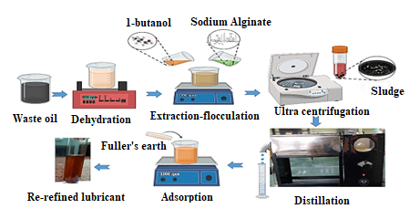

|  |  |
| --- | --- |
| **Percentage yield of recovered oil** = $\frac{Weight of recovered oil }{Weight of used oil}$\* 100 | (2) |

*Figure 2: Process flow diagram of extraction-flocculation*

* + 1. Design of experiments by L9 orthogonal array

Dr.Genichi Taguchi developed the Taguchi method, that investigates the influence of each operational constraint on performance characteristics and also determines which parameter is the most influenced among all other variables that are chosen for designing the model (Dhawane et al., 2018). The levels of independent variables, experimental matrix for maximising percentage yield of recovered oil using Taguchi L9 method are summarised in Table 1 and Table 2 respectively. N represents the total number of runs, which is highly dependent on the total number of parameters indicated by P, and L represents the level of each parameter as shown in Eq(3).

|  |  |  |
| --- | --- | --- |
| N=(L-1)P+1 |  | (3) |

Table 1: Parameters and their levels for L9 orthogonal array

|  |  |  |  |  |  |
| --- | --- | --- | --- | --- | --- |
| Coded Parameters | Factors | Units | Levels | | |
|  |  |  | -1 | 0 | +1 |
| A | Refining time | min | 60 | 80 | 100 |
| B | Reaction temperature | ℃ | 40 | 60 | 80 |
| C | Solvent: Waste Oil | - | 3:1 | 5:1 | 7:1 |
| D | Flocculant Concentration | g/kg of solvent | 1 | 2 | 3 |

Table 2: Experimental Design matrix for maximising percentage yield of recovered oil using Taguchi L9

|  |  |  |  |  |  |  |
| --- | --- | --- | --- | --- | --- | --- |
| Run No. | Solvent: waste  oil (w/w) | Reaction Temperature  (°C) | Reaction  Time  (minute) | Flocculant Concentration  (g/kg of solvent) | Yield of  refined oil (%)  Experimental value | Signal-to-noise ratio of refined oil |
| 1 | 5:1 | 60 | 60 | 2 | 84.13 | 38.50 |
| 2 | 7:1 | 60 | 80 | 1 | 82.18 | 38.30 |
| 3 | 3:1 | 60 | 100 | 3 | 83.89 | 38.47 |
| 4 | 5:1 | 40 | 80 | 3 | 87.25 | 38.82 |
| 5 | 3:1 | 40 | 60 | 1 | 87.69 | 38.86 |
| 6 | 7:1 | 80 | 60 | 3 | 91.58 | 39.24 |
| 7 | 5:1 | 80 | 100 | 1 | 91.45 | 39.22 |
| 8 | 3:1 | 80 | 80 | 2 | 92.11 | 39.29 |
| 9 | 7:1 | 40 | 100 | 2 | 87.72 | 38.86 |

* 1. Results and Discussion
     1. Fourier-transform infrared spectroscopy of virgin, waste and recovered lubricating oil

Figure 3 depicts the FTIR analysis of fresh lubricant, waste lubricant, and re-refined base oil. Figure 3 shows that various bands in virgin lubricating oil represented by the peaks 2951 cm-1, 2920 cm-1, and 2850 cm-1 (Kupareva et al., 2013) are assigned to symmetric stretching of the C-H group (alkane). The peak at 1463 cm-1, belongs to the CH2 group (alkane), and the absorbance at 1373 cm-1 indicated CH3 group (Khalaf et al., 2021). In waste lubricating oil the peak at 1175 cm-1, indicated the presence of carboxylic acid (Abu-Elella et al., 2015). One band in the spectra is associated to carbonyl compounds with symmetric stretching of the C=O from esters, ketones, or acids, and it is located at 1700 cm-1. (Kupareva, Mäki-Arvela and Murzin, 2013). At 2730 cm-1, a stretching vibration of H-C=O: C-H (aldehydes) appears(Abu-Elella et al., 2015). The spectra at 820 cm-1 in waste oil is assigned to aromatic content, which indicates that waste lubricating oil content fuels (Abu-Elella *et al.*, 2015). After the re-refining process using 1-butanol as solvent and sodium alginate as flocculant, aromatics, aldehyde, and other oxidative products such as ketones, carboxylic acid was eliminated from the re-refined base oil and this confirms by the absence of peaks at 820 cm-1, 1700 cm-1.

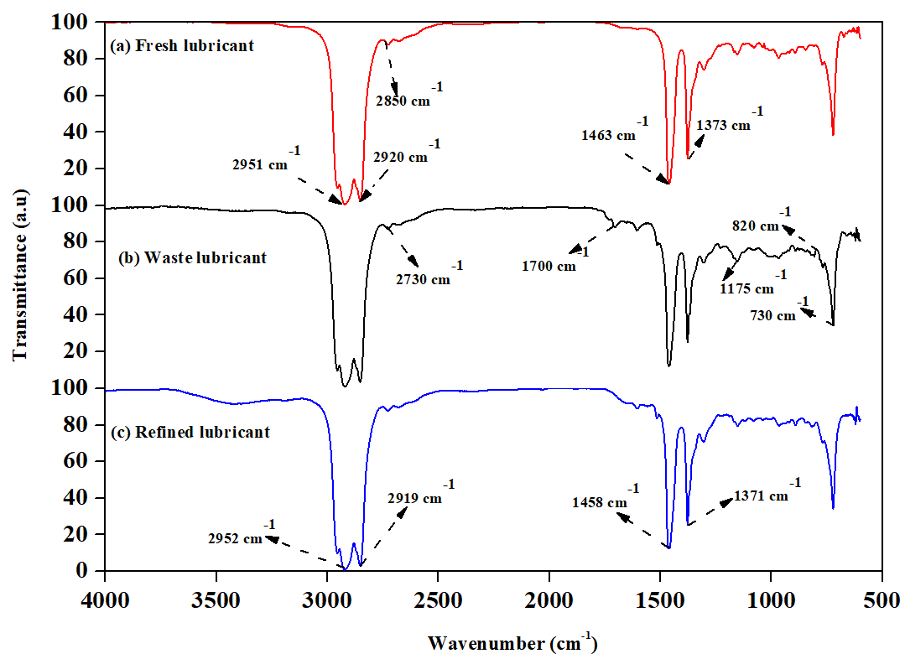

*Figure 3: FTIR analysis of (a) Fresh Lubricant (b) Waste Lubricant and (c) Refined Lubricant*

* + 1. Analysis of variance (ANOVA) of re-refining waste lubricating oil using Taguchi approach

The Taguchi approach was used to design an experimental matrix for re-refining waste lubricating oil using eco-friendly and cleaner extraction-flocculation technology to maximise the percentage recovery of re-refined base oil. Table 3 summarises the results of the analysis of variance from the three-factor interaction for maximising the percentage yield. The obtained sum of squares and model’s F-value in the current investigation are 105.66, and 53.86 respectively which is sufficient to demonstrate its significance. Table 3 shows that the most influential parameter is refining temperature, followed by flocculant dosage, and the solvent to waste oil ratio. The results of the percentage contribution of each process parameter were obtained and summarised in Table 4 by estimating the contribution factors. According to the finding’s, refining temperature has the greatest influence on percentage yield, with a contribution factor of 98.11 % followed by flocculant dosage of 1.09 % and solvent to waste oil ratio of 0.78 %. The Model fit statistics for re-refining process was evaluated and tabulated in Table 5. The experimental results are completely predicted by the model, according to the co-efficient of determination (R2), which was found to be 0.9938. The lower values of the coefficient of variance (0.65 %) provided a clear understanding of the model's correctness. The total signal-to-noise ratio (adequate precision) for the selected model was 19.6908, indicating that there is enough signal to navigate the design space based on the findings of the current experiment.

Table 3: Statistical analysis for maximisation of the yield of recovered oil

|  |  |  |  |  |  |  |
| --- | --- | --- | --- | --- | --- | --- |
| Source | Sum of squares | df | Mean square | F-Value | P-Value | Comments |
| Model | 105.66 | 6 | 17.61 | 53.86 | 0.0183 | Significant |
| B-Refining Temperature | 103.67 | 2 | 51.83 | 158.52 | 0.0063 |  |
| C-Solvent to waste oil ratio | 0.8274 | 2 | 0.4137 | 1.27 | 0.4415 |  |
| D-Flocculant Dosage | 1.16 | 2 | 0.5815 | 1.78 | 0.3599 |  |
| Residual | 0.6540 | 2 | 0.3270 |  |  |  |
| Cor Total | 106.31 | 8 |  |  |  |  |

Table 4: Percentage contribution of each process parameters on recovered oil yield

|  |  |
| --- | --- |
| Parameters | Contribution factors (%) |
| Refining temperature (℃) | 98.11 |
| Solvent to waste oil (g/g) | 0.78 |
| Flocculant dosage (g/kg of solvents) | 1.09 |

Table 5: Model Fit statistics

|  |  |  |  |
| --- | --- | --- | --- |
| Std. Dev. | 0.5718 | R² | 0.9938 |
| Mean | 87.56 | Adjusted R² | 0.9754 |
| C.V. % | 0.6531 | Predicted R² | 0.8754 |
| PRESS | 13.24 | Adequate Precision | 19.6908 |

* + 1. Optimum condition and validation of model

The operational parameter of eco-friendly extraction-flocculation process is being optimised to find the best parametric conditions for the maximisation of re- refined oil yield. To achieve a maximum conversion of 91.31 %, the following conditions were found to be optimal: (i) refining temperature - 80 ℃; (ii) refining time - 60 minutes; (iii) solvent-to-waste oil ratio - 3:1 g/g and (iv) flocculant concentration -1 g/kg of solvent. Table 6 summarises the optimum conditions for re-refining waste lubricant using Taguchi L9 orthogonal array.

Table 6: Optimum condition for maximising the yield % using Taguchi L9

|  |  |
| --- | --- |
| Parameters | Optimum Conditions |
| Refining Temperature (℃) | 80 |
| Refining Time (minutes) | 60 |
| Solvent to waste oil (g/g) | 3:1 |
| Flocculant dosage (g/kg of solvents) | 1 |

* + 1. Fuel characteristics

Table 7 shows the physicochemical properties of a virgin, waste and re-refined lubricating oil with extraction-flocculation process. As a result of the presence of light ends in waste oil, the flash point of waste engine oil was reduced to 180 ℃, whereas, the flash point of virgin lubricating oil is 240 ℃. After the regeneration, the flash point of refined oil was increased considerably to the tune of 234 ℃, which implies satisfactory removal of remaining solvent, light ends and carbonaceous particles from waste oil (Mohammed et al., 2013). Table 7 shows that the specific gravity of recovered oil is close to that of fresh oil. According to the results, the pour point of used oil (-27 ℃) is higher than that of fresh oil (-35 ℃) due to degradation of additives. Pour point of recovered oil was -33 ℃. This was due to the exclusion of degraded additives and oxidative products. The kinematic viscosity of used oil @40 ℃ and @100 ℃ are 115.38 cSt and 14.30 cSt respectively. In contrast, the Kinematic viscosity of recovered oil @40 ℃ and @100 ℃ are 155.21 cSt and 17.11 cSt, respectively. It is evident from the result of the physicochemical characteristics of refined oil that the improvement of kinematic viscosities is mainly because of the precipitation of condensed products and oxidised products as sludge (Mohammed *et al.*, 2013).

Table 7: Physicochemical Characteristics of virgin, waste and refined lubricating oil

|  |  |  |  |
| --- | --- | --- | --- |
| Properties | Virgin lubricating oil | Waste lubricating oil | Re-refined lubricating oil |
| Kinematic Viscosity, @40℃ | 164 | 115.38 | 155.21 |
| Kinematic Viscosity, 100℃ | 18.75 | 14.30 | 17.11 |
| Specific gravity | 0.85 | 0.887 | 0.849 |
| Viscosity Index | 183.60 | 118.10 | 182.22 |
| Flashpoint (℃) | 240 | 180 | 234 |
| Pour point (℃) | -35 | -27 | -33 |
| Total Acid Number (TAN)  mg of KOH /g of oil | -- | 2 | 0.33 |
| Ash Content (ppm) | 0.3 | 2 | 0.26 |
| Zn |  | 912 | 325 |
| Mn |  | 832 | 459 |

* 1. Conclusion

The present study focused on synthesis of bio-flocculant (sodium alginate) from brown algae (*Sargassum Muticum)* followed by optimising process parameters by the Taguchi approach for re-refining of waste lubricating oil. There exhibits a considerable improvement of flocculation efficiency while treated with synthesized biopolymer flocculant compared to inorganic flocculant, which is reflected in the improvement of % recovery of re-refined oil (by 5 % improvement) and its quality parameters after treatment (in enhancement in flash point, kinematic viscosity @40 ℃, reduction of total acid number etc.). The result obtained from the study revealed that the reaction temperature affects the re-refining process significantly compared to other chosen parameters, with a contributing factor of 98.11 %, followed by flocculant doses of 1.09 % and solvent-to-oil ratio of 0.78 %. The optimum condition obtained from re-refining of waste lubricating oil are: reaction temperature of 80℃, reaction time of 60 minutes, solvent-to-oil ratio of 3:1 g/g and bio-polymeric flocculant (developed sodium alginate) concentration of 1g/kg of solvent to achieve maximum yield of re-refined base oil conversion as 91.31 %. The statistical analysis from the ANOVA study demonstrates that the model can competently optimise the process with accurate prediction. Thus, the Taguchi method's L9 orthogonal array approach effectively optimises and identifies the significant operational parameters of waste lubricating oil recycling. Moreover, the fuel characteristics of re-refined lubricating base oil are comparable to the virgin base oil. Thus, the regenerated base oil may be used commercially as a good lubricant after adding the required quantum of additives for a specific function.

References

Abu Elella R., Ossman M.E., Farouq R., Abd Elfatah M., 2015, Used motor oil treatment: turning waste oil into valuable products, Int. J. Chem. Biochem. Sci, 7, 57-67.

Bertagnolli C., Espindola A.P.D., Kleinübing S.J., Tasic L., Da Silva M.G.C., 2014, Sargassum filipendula alginate from Brazil: Seasonal influence and characteristics, Carbohydrate polymers, 111, 619-623.

Botas J.A., Moreno J., Espada J.J., Serrano D.P., Dufour J., 2017, Recycling of used lubricating oil: Evaluation of environmental and energy performance by LCA, Resources Conservation and Recycling, 125, 315-323.

Chen X., Si C., Fatehi P., 2018, Cationic xylan-(2-methacryloyloxyethyl trimethyl ammonium chloride) polymer as a flocculant for pulping wastewater, Carbohydrate polymers, 186, 358-366

Dhawane S.H., Karmakar B., Ghosh S., Halder G., 2018, Parametric optimisation of biodiesel synthesis from waste cooking oil via Taguchi approach, Journal of environmental chemical engineering, 6(4), 3971-3980.

Jayasinghe G.D.T.M., Jinadasa B.K.K.K., Sadaruwan N.A.G., 2022, Pathway of sodium alginate synthesis from marine brown algae, Sargassum wightii from Sri Lanka, Discover Food, 2, 1-7.

Khalaf I.H., Al-Sudani F.T., AbdulRazak A.A., Aldahri T., Rohani S., 2021, Optimization of Congo red dye adsorption from wastewater by a modified commercial zeolite catalyst using response surface modelling approach, Water Science and Technology, 83(6), 1369-1383.

Kupareva A., Mäki Arvela P., Murzin D.Y., 2013, Technology for re-refining used lube oils applied in Europe: a review, Journal of Chemical Technology & Biotechnology, 88(10), 1780-1793.

Mahmoud M.S., Mohamed S.A., 2017, Calcium alginate as an eco-friendly supporting material for Baker’s yeast strain in chromium bioremediation, HBRC journal, 13(3), 245-254.

Mensah-Brown H., 2015, Re-refining and recycling of used lubricating oil: An option for foreign exchange and natural resource conservation in Ghana, ARPN Journal of Engineering and Applied Sciences, 10(2), 797-801.

Mohammed R.R., Ibrahim I.A., Taha A.H., McKay G., 2013, Waste lubricating oil treatment by extraction and adsorption, Chemical Engineering Journal, 220, 343-351.

Osman D.I., Attia S.K., Taman A.R., 2018, Recycling of used engine oil by different solvent, Egyptian Journal of Petroleum, 27(2), 221-225.

Renault F., Sancey B., Badot P.M., Crini G., 2009, Chitosan for coagulation/flocculation processes–an eco-friendly approach, European Polymer Journal, 45(5), 1337-1348.

Saji S., Hebden A., Goswami P. and Du C., 2022, A brief review on the development of alginate extraction process and its sustainability, Sustainability, 14(9), 5181.

Sarkar S., Datta D. and Das B., 2022, Advance recovery approach for efficient recovery of waste lubricating oil by different material formulation, Materials Today: Proceedings, 49, 1891-1898